TIME SERIES DATA ANALYSIS AND FORECAST METHODS

Lecture 4
Time series decomposition into components

Yekaterinburg
2017
Contents

Lecture purpose 3

Lecture map 3

Part 1. Time series separability 4

Part 2. Trend estimation for time series 7
2.1. Basic curve fitting of trend with regression 8
2.2. Smoothing techniques 14

Part 3. Periodic components retrieval from stationary time series 16

References 19

Lecture purpose
The purpose of this lecture is to introduce the students to traditional methods of time series decomposition into the components, studying of features of techniques of these methods, and also formation of knowledge and abilities of time series reconstruction.

Lecture map

- Definition of time series separability
- Decomposition of stationary time series
- Trend estimation with regression methods
- Trend estimation with smoothing methods
- Periodic components retrieval from stationary time series

Part 1. Time series separability
In the very first lecture we defined a class of models which will interest us most of all in practice. The additive model consisting of several components concerns to those:
, (4.1)
where 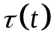– trend ( or tendency); 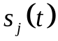– j seasonal component, in any model there can be several о them (monthly, quarter, yearly, etc.); 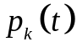– k periodic (cycle) component, in any model there can also be several оf them; 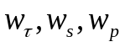 – coefficients of presence or lack of components, can be in values оf 0 or 1; 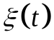 - stochastic variable.
As a component we will understand two different types о splitting parts о the initial time series data 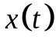. With first algorithm we are interested in the decomposition of time series into deterministic and stochastic parts of data. Initially interests us whether there are both of these parts in investigated by TS, or one of them is absent. With it we will be helped by the checks of statistical hypotheses listed in the third lecture. If at a row the deterministic component is present, on the second algorithm we are actually interested in types a component, such as trend, seasons and cycles more.
The possibility of decomposition initial TS on these principal components making it is described by a concept of divisibility of TS. Let the time series 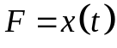 be an additive sum оf m components and our task is to divide this time series into exactly m additive modes. There is a question: whether we can apply some algorithms in the principle to recover from initial TS these m components? The theory of separability is engaged in this question.
Let 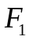 and 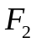 – time series оf length N and 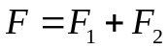. Each of these ranks at decomposition by the most different methods will generate (for example, on to basis of singular decomposition) linear spaces 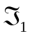 and 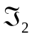.
Let's say, that TS and are weakly separable, if 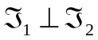, thus bases оf these spaces should be orthogonal. If those TS and are weakly separable and at the same time also bases of linear spaces and are not crossed (that is have no equal eigenvalues), such TS will be already strongly separable. Additively increasing the number оf components , , 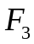 to the desirable number m, it is possible to determine similarly strong divisibility of m of time series.
It turns out that if ranks are strongly separable, then there is a method, which will allow unambiguously from initial to TS to receive these desirable components in their initial type, that is the model (4.1) will be exact. Therefore often such type of divisibility is called exact separability.
Such theoretical determinations well sound and encourage in that, that TS can be broken, divided or decomposed on compound components. In practice everything is slightly more sad. It appears exact separability is not achievable even for a combination of some types of ranks at total absence of noise. That is strong separability turns out so "strict" that even not any additive sums determined a component without noise can be decomposed into components. With respect thereto, instead of exact separability of ranks (a theoretical limit), we use approximate and asymptotic separability. Let's remind that a separability condition makes a start from orthogonality of the generated vector spaces . An indicator of a measure of this orthogonality, or, speaking in language of probability theory, is the independence of two TS and , can serve the correlation coefficient 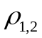 оf these two samples. If is close to zero, than and are more independent. This fact is also used for determination approximate and asymptotic separability.
Time series and are approximately separable, if 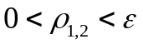 at some small . If at the same time number of observations of TS is 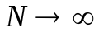, at accomplishment of a condition of 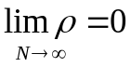, TS and would be asymptotically separable.
Asymptotic separability in practice meets seldom, and the divisibility which here is brought closer allows to put it already into practice. Most widely we will meet a concept of divisibility of ranks at the description of a method of singular spectrum analysis which in is much constructed just on the theory of strong and weak divisibility of time series.

Part 2. Trend estimation for time series
For stationary TS as it was already shown earlier, is very important a problem of splitting a row into the determined and accidental components, at the same time the determined part in the analysis practical TS, most often it is segmented in the form of additive model:
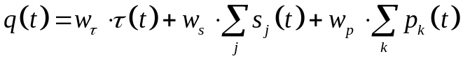 (4.2)
Let's remind that on this model (4.2), the nonrandom component may contain (or not) a trend/tendency, seasonal components and cyclic components. If to concentrate attention on receiving determined part of TS, then as the basic model is additive, TS can receive a stochastic component of a data just as a difference initial and its found determined part, that is in the form of a number of remaining errors. For this reason the problem of decomposition of stationary time series always comes down to a problem of selection of the determined component of TS and its separation into compound components agrees (4.2) or some other model.
Among all parts of additive model (4.2) the simplest according to the characteristics the trend therefore in the majority of methods (but not in all) at first try to select trend component of a row looks.

2.1. Basic curve fitting of trend with regression
The trend from (4.2) reflects influence of long-term factors and corresponds to a long-term and steady trend of change of TS. For this reason, the trend is also used often as the long-term and mid-term forecast.
The problem of selection of a trend comes down to a problem of estimation (or fitting) to the basis function 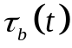 with the set sample 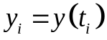 оf data. For simplification, it is supposed that the others components of a TS are not present (4.2) or their influence in TS is insignificant, or the condition about approximate separability of components of a row is satisfied. For a trend component in respect of a concept of divisibility everything appears rather well – even in the presence of noise the majority of types of a trend is selected on the terms of exact separability, except for a form of trends of high degree of a polynomial.
So, if TS by statistical tests was determined as stationary, the analysis of autocorrelation function (or statistical tests) shows existence of a trend in selection, it is possible to start selection of a trend. There are two groups of methods of selection of a trend of TS: methods of regression analysis (do not confuse with autoregressive methods!) and methods of smoothing. Because of wide use of the second group of methods, very often the problem of selection of a trend is called a problem of smoothing time series.
Let's begin with regression methods of selection of a trend. In this group methods the model (4.2) comes down to the simplified form
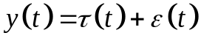 , (4.3)
where 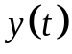 – initial time series, – trend, 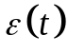 – stochastic residue with cycles and seasons.
At the same time at an stochastic variable the expectation value is supposed to be close to zero and variance is 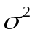. Note, that everything that has a mean other than zero has to be carried to a trend. Such statement is not accidental here – as we will see further, for divisibility seasonal and cyclic the component will have very important the zero average level. Even for the ARIMA models often it is necessary to normalize data to some near-zero level.
Knowing a required form оf trend , estimated trend approximated or fitted on the basis of counting from selection by methods of pair regression. The theory of these methods is very extensive and in detail is considered on other courses of this discipline, here we will be interested only in some special cases from it for a solution of specific objectives.
Depending on a trend type, different functions of adjustment will be used. Trends have several types:
- Linear
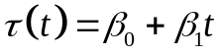 (4.4)
- Quadratic
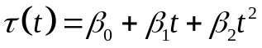 (4.5)
- Polynomial
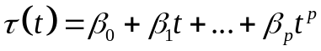 (4.6)
- Exponential
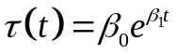 (4.7)
- Logistic
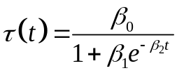 (4.8)
- Non-linear form (all others).
The choice of a form of a trend, strangely enough, is often made visually. If visually determination is complicated, build polynomial trends, gradually raising their degree of p until the satisfactory result is received.
When using (4.6) it is very important to recognize the closest to required p polynomial degree. For its initial assessment the method of consecutive differences is used:
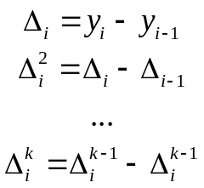 (4.9)
For each such line of differences we calculate
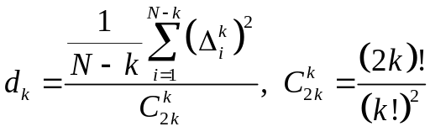 , (4.10)
This value (4.10) originally decreases with growth k, and then, since some k₀, is stabilized at one level. Then polynomial degree is selected as 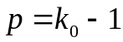.
After the choice of a type of function (4.4) – (4.8) build the regression equation, depending on the coefficients b_{i}, which are estimates of coefficients 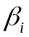. On order to operate with less various special cases, constructions of linear regression are used by the generalized the least squares method.
The central condition of this method is the minimization condition sums of squares of deviations:
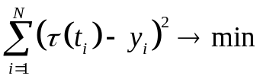 . (4.11)
In case of use of nonlinear functions, or replace variable regressions with the corresponding functionalities, or make replacement of a variable through the conversions linearizing the regression equations. For example, the model of a trend is supposed to be multiplicative:
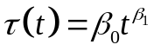 . (4.12)
Then, making logarithming of TS and model we receive
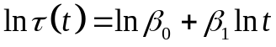 , (4.13)
and, then, by a change of variables it is a linear regression now:
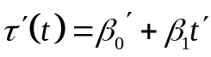 . (4.14)
But we will return to the generalized linear model of multiple regression. Let the model of a trend have an appearance (where x can be replaced with functions from t):
. (4.15)

In a matrix type it denoted as:
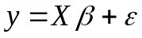 , (4.15а)
where 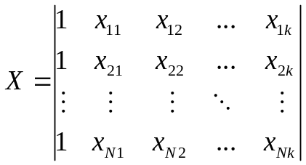,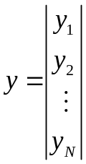,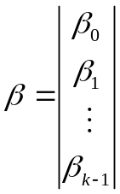,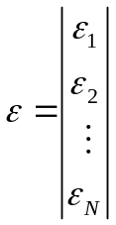 . (4.16)
At the same time we assume that the matrix X – is not random, vector has a zero mean and is an uncorrelated stochastic variable, rank оf matrix X is 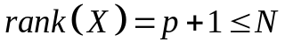. Such regression (4.15) is called then the generalized linear model of multiple regressions.
Solving this matrix equation expression will be b, the best to be relative assessment among all set of solutions:
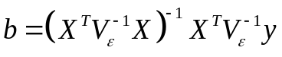 . (4.17)
where 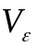 – a covariance matrix of errors.
The problem consists that in practice on hands we have no such matrix. If it is absent, then it can be evaluated. There are two methods it to make.
The first method relies on statistical estimates of an accidental component and on conditions of approximate separability of time series. Without pressing in depths of theoretical calculations, at once we will give expression for assessment of the reciprocal covariance matrix of errors:
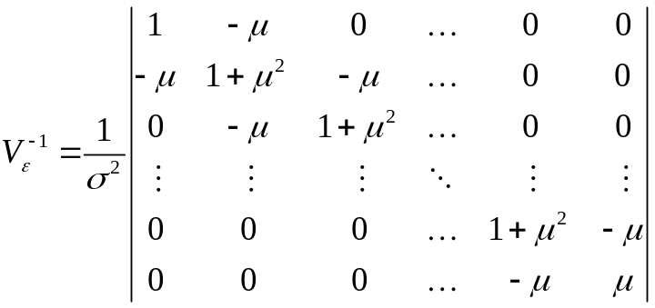, (4.18)
where 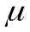 – expectation value оf estimated AR model, – variance of estimated AR model. For a final formula we lack still these two estimates.
These parameters evaluate by means of the following iterative algorithm:
- Estimate the 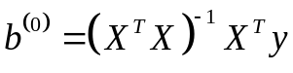 on the iteration step l = 0.
- Calculate the discrepancy 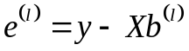.
- Find the 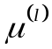 from equation
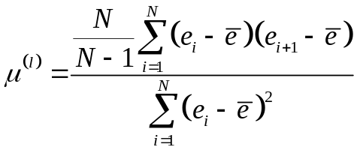 (4.19)
and from it we define 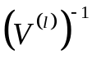 with (4.18), assuming for now 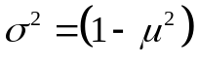.
- Estimate the vector
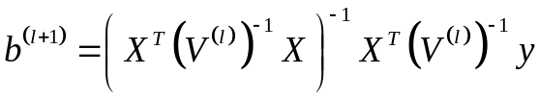 (4.20)
and increment the step: l = l + 1.
- Repeat the steps 1-3, until the difference between 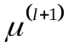 and is small.
- With found 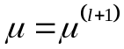 we estimate the
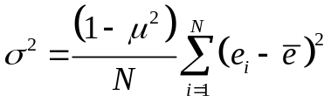. (4.21)
The much needed estimations of and are found.
But we spoke about two methods of assessment of a covariance matrix of errors. The second method is not even assessment, it is the assumption that errors are not correlated among themselves rather, and 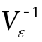 will be a unit scalar matrix I. From here we go to the general method of regression creation:
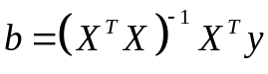 . (4.22)
Thus, by one of two techniques, we found the 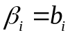 оf (4.15) and, by calculating the tendency on the set temporary grid of TS, the trend will be found.

2.2. Smoothing techniques

Different from regression methods of selection of a trend, these methods evaluate components of a time series only in certain instants of initial TS, the smoothing set by a window.
Let's define trend assessment as a weighted average of the original values of a row which are in a smoothing window:
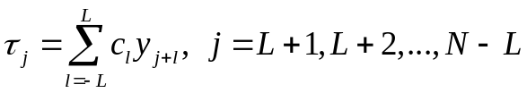 , (4.23)
where 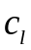 – weighting coefficients with a condition 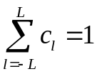.
It is visible, that L values at the left and to the right of y_{i} are summed. Length of an interval of summing is a window of smoothing which as if “smoothes” on input data. Depending on the choice of weight factors c_{l} types of smoothing will change.
The simplest smoothing will be the smoothing average in which multipliers are fixed by window length (2L + 1) and select as:
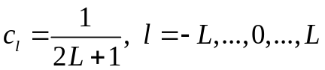 (4.24)
For example, with L = 1, the window length is 3, and the smoothing method is simply 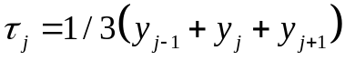.
It is possible to notice that expression (4.23) corresponds to filtering in frequency domain of selection of the set process therefore often similar methods are called rectifier filters, and also consider some of their types, depending on application of the corresponding types of filters.

It should be noted only one more type of the sliding average which is often found in practice – exponential smoothing. For this smoothing all counting initial TS, but with different weight factors used already.
The general expression of exponential smoothing looks as:

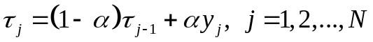 (4.25)

where  – coefficient of exponential smoothing between 0 and 1, and as the first point undertakes mean value of TS (or the first two points).
This smoothing differs from (4.23) those that weight here, in fact decrease with removal from a point of the beginning of smoothing. Expression (4.25) very conveniently for the fact that it is based recursively (the following value depends on previous), and therefore can easily be used for forecasting of a trend of TS.

Part 3. Periodic components retrieval from stationary time series
According to model (4.2) in any TS can be several seasonal and periodic component (cycles). Let's remind that the difference between seasonal components and a cycle is purely formal: one of them is supposed quasi-periodic, and another strictly periodic. In practice, strangely enough, even more simplified version of department of these two concepts is used: cycles have the period much more, than seasonal components. Such interpretation of initial sense a component arose because in practice more long-period components are less subject to fluctuations in time (cycles), than short-period seasons.
As distinction between these components is minimum (especially from the point of view of mathematical statistics), let’s call them the trigonometric components.
Before to look for these components, initial TS is analyzed by means of autocorrelation and spectral methods to understand whether there are trigonometric components in a row in general. Then from an initial row remove "an average tendency" as which the trend which methods of selection were described above acts. At an opportunity, also try to remove noise from the analyzed row. Then, according to additive model (4.2) we will have part of TS containing only trigonometric components.
Then trigonometric components can try to be selected by means of the spectrum Fourier analysis. At once we will stipulate that into practice this method will be we will put very seldom as further we will provide the whole requirements list, put forward to initial by TS that this technique earned.
Let's assume that periodic function 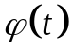 is a continuous function with T period. Then this function is possible to decompose in a Fourier time series:
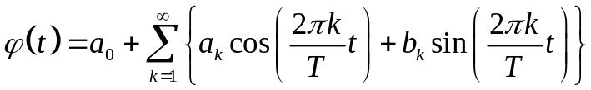 . (4.26)
With increase in number of harmonic, the period of functions cos and sin will decrease. Coefficients of decomposition can be evaluated with:
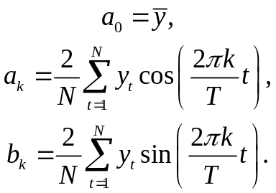 (4.27)
If now we relate expression (4.26) to definition of a periodogram, then it is possible to note, that power contribution of k-harmonic can be defined as 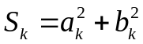. Periodogram exactly builds this type оf estimation 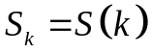, therefore it is possible to find these principal harmonic components from the initial time series data with PSD estimation.
For selection corresponding trigonometric components, a Fourier series (4.26) is under construction not entirely, and partially, only for those harmonic components that will be present in selected a component:
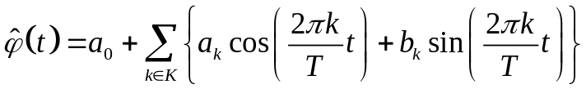 (4.28)
Then from TS each periodical press, starting with that which has the greatest power contribution is eliminated until there is some residual row without the periodical presses.
In general such search algorithm and selections trigonometric component looks good and simply. In practice applicability of this technique is significantly limited, owing to requirements to initial TS.
So, we will list requirements to properties of an initial time series, which it has to possess that its trigonometric components were possible to be selected through a Fourier series.
First, the TS has to be stationary that was more than once mentioned. Secondly, conditions of the Nyquist-Shannon sampling theorem in relation to the periods a component and the frequency of temporary selection have to be satisfied. Thirdly, because of the limited length of a time frame, in spectral area of a row there will be spectral leaks therefore instead of expected "peaks" of harmonics there will be their sinc-approximations, that is exact values of harmonics will be blurred. Fourthly, Fourier transform has the fixed frequency permission therefore trigonometric components with the floating period will be poorly separable from TS, or are not selected in general. Fifthly, if frequency components are not multiple to number of harmonic of Fourier, then such a component it is considered poorly separable too. Well and, at last, if trigonometric component of a TS is frequency modulated, that is its period is a function of time, such component is not defined by Fourier's decomposition and, therefore, is not selected from initial TS.
Thus, it turns out that a type trigonometric a component, which can be selected through spectrum analysis, it is significantly limited. As then arrive in this case. As we will see further, there is a number of adaptive methods of the analysis and decomposition of the time series which are not putting forward any special requirements to a row and components that allows to decompose initial TS on harmonious components without any limit.

References

1. N. Golyandina, A. Zhigljavsky. Singular Spectrum Analysis for time series. — Springer Briefs in Statistics. — Springer. — 2013. — 120 p. ISBN 978-3-642-34912-6.
2. David R. Brillinger. Time Series: Data Analysis and Theory. — SIAM, 2001. — 540 p.

